LOW LEVEL DESIGN DOCUMENT

For

CRIMINAL MANAGEMENT SYSTEM

Aaditya Bisaria-PES2UG21CS002 Aditi Khasnis-PES2UG21CS031 Alekhya Ponnekanti - PES2UG21CS055

Amogh Firke -PES2UG21CS059

***PES University EC Campus, Section 5A***

USE CASE DIAGRAM:

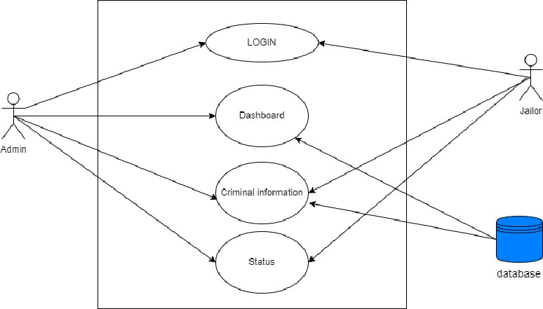

Architecture Diagram:

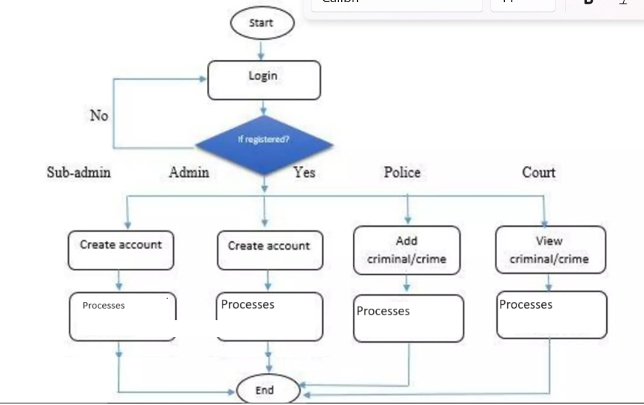

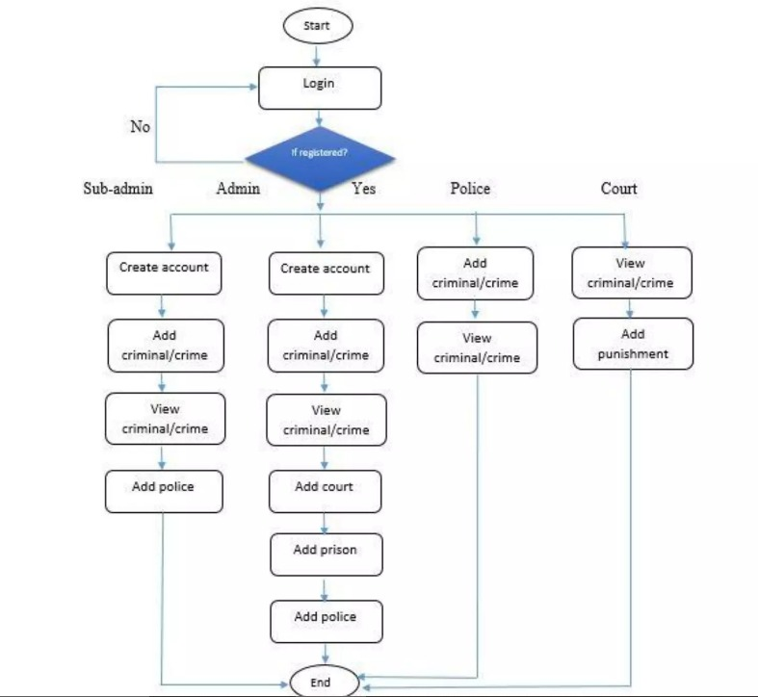

CLASS DIAGRAM:

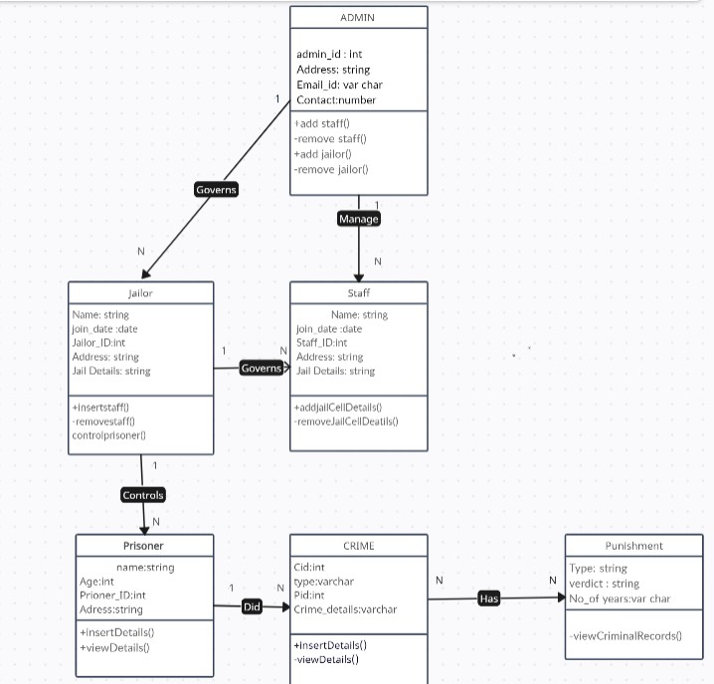

DFD LEVEL 0:

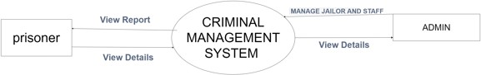

DFD LEVEL 1:

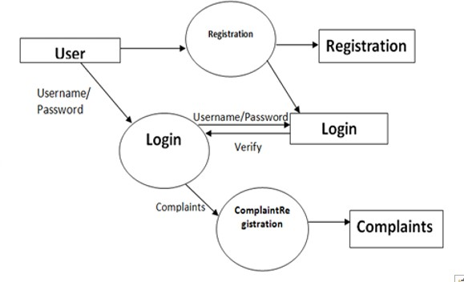

DFD LEVEL 2:

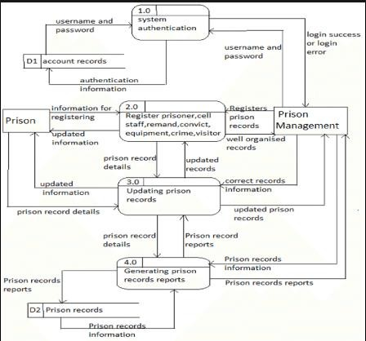

Architecture Style:

**Layered architectural style** to a Criminal Management System (CMS) to achieve modularity, maintainability, scalability, and improved system performance. Here's how you can adapt this architectural style to a CMS:

* Presentation Layer (User Interface):

In the context of a Criminal Management System, the presentation layer would include user interfaces for administrators, law enforcement personnel, and other authorized users. Components in this layer would include web interfaces, desktop applications, or mobile apps for accessing and managing criminal data.

The user interface should allow users to input and retrieve information related to crimes, suspects, evidence, and legal cases.

Application Layer (Business Logic):

This layer contains the core business logic and functionalities of the CMS. It deals with the processing and management of criminal data.

Components in this layer would include:

Crime data management: Adding, updating, and deleting crime records.

Suspect and offender data management: Managing information about suspects, offenders, and their legal status.

Legal case management: Handling case information, court proceedings, and legal documentation.

Evidence management: Storing and managing evidence related to criminal cases.

User authentication and authorization: Implementing security features to control access to the system.

Report generation: Creating reports and analytics related to criminal data. Data Layer (Database):

This layer is responsible for data storage and retrieval. In the case of a CMS, it manages data related to crimes, suspects, legal cases, and evidence.

Components in this layer include:

Database Management System (DBMS): Choose an appropriate database system (e.g., MySQL, PostgreSQL, or NoSQL databases like MongoDB) for storing the data

Data Access Layer: This layer handles the communication between the application layer and the database. It includes functions and procedures for CRUD (Create, Read, Update, Delete) operations on the database.

Benefits of Layered Architecture for a Criminal Management System:

Scalability: Each layer can be independently scaled to accommodate changes in demand. For example, you can scale the presentation layer to support more users without affecting the core business logic or data layer. This scalability ensures improved responsiveness during peak times without compromising system stability.

Maintainability: Changes or updates made to one layer do not necessarily impact the other layers. This separation simplifies system maintenance, reduces the risk of unintended side effects, and allows developers to focus on specific layers without having to understand the entire system.

Performance: The distribution of responsibilities and core functionalities across layers results in more efficient system performance. With clear separation of concerns, it's easier to optimize and enhance each layer independently.

By following the Layered architectural style, a Criminal Management System can be well- organized, modular, and maintainable, ensuring the clarity of data management and efficient system performance, which is crucial for a system handling sensitive criminal information and processes.